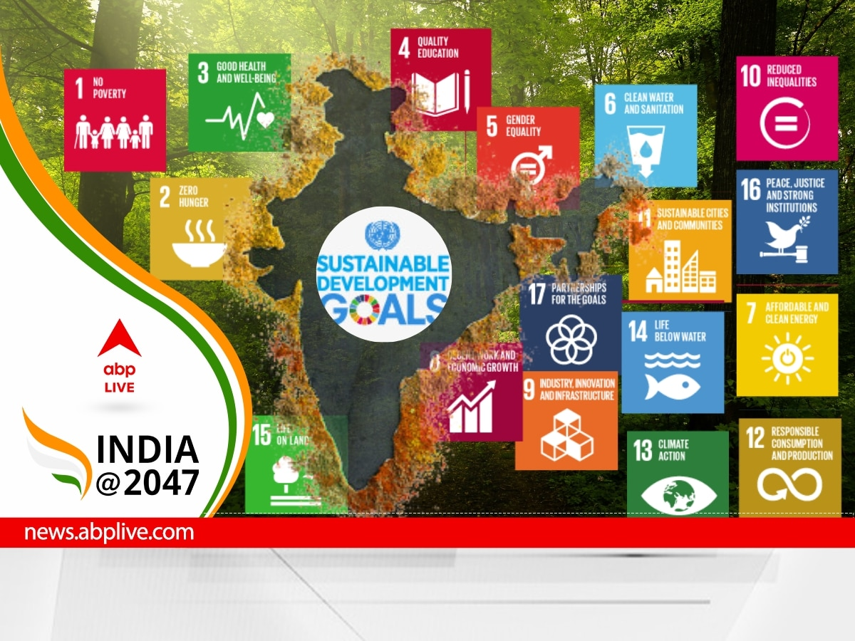



**SDG INDEX REPORT**



Sustainable Development Goals

Report 2023

Rutuja Kalugade | Data Analyst | 15/9/202

**BUSINESS PROBLEM:**

India has set ambitious goals for itself to achieve the Sustainable Development Goals (SDGs) by 2024. Some of the key goals that the country is working towards include:

1. No Poverty : India aims to reduce the poverty rate to less than 10% by 2024.
2. Zero Hunger: India aims to achieve zero hunger by 2024.
3. Good Health and Well-being:
4. Quality Education:
5. Gender Equality:
6. Clean Water and Sanitation:
7. Affordable and Clean Energy: The government is investing heavily in renewable energy technologies.

So here we do analysis on the Sustainable Development Goals index which are achieved by India in 2023 that will help us to determine overall performance of India till 2023. From this we can find out about –

How India is working towards the sustainable development goal? What should our steps towards achieving goals and focusing on the other developed countries ,comparing with themselves to find out our strategy.

**ASSUMPTIONS:**

For our analysis we are going to taken some assumptions for the dataset and analysis SDG’s

1.The information is still current and can be used to analyze India’s possible SDG’s plans in an efficient manner.

2.There are no anticipated negatives by govt or any research institute, organization for any advised techniques.

3.The organization ,govt etc. are not currently using any of the suggested solutions.

4.No outliers in this dataset that affecting the data.

**RESEARCH QUESTIONS:**

1.How India is working towards the sustainable development goal?

2.Will India be able to achieve SDG goals by 2024?

3.What is the status of sustainable development in India 2023? What are the challenges faced by India in attaining SDGs?

4.What are main substances which determine SDG’s goals success?

5.Our nation set some ambitious goals is it possible to reach this or not?

**HYPOTHESIS:**

1.India is moving towards achieving goals due to development in all fields still running such as education, healthcare, science etc.

2.Our govt continuously working on different schemes for our development

3.Most of population of india is youth generation so this is one of the strength for holding success towards SDG’s.

4. There are still some drawbacks in implementing SDG’s, this is because we haven’t make any strong decision regarding SDG’s ,we have to compare others country that how make use of population to achieve their goals .

**ANALYSIS and FINDINGS:**

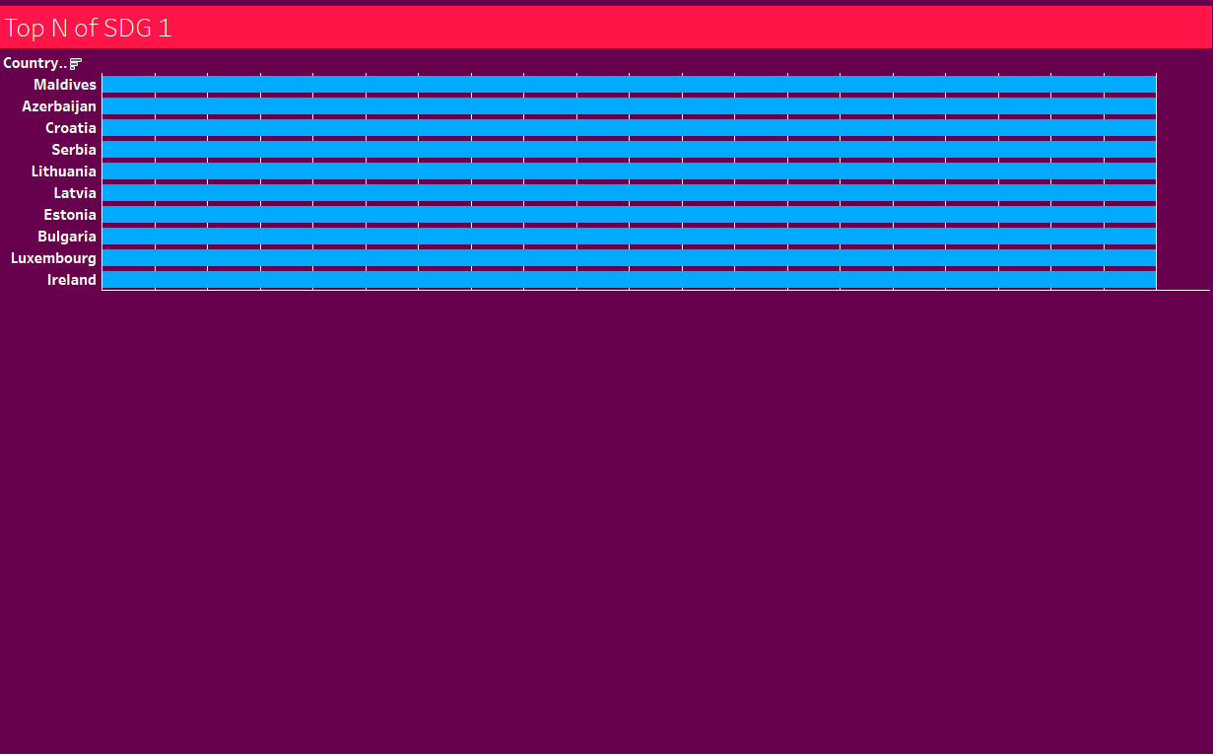

Here we can see that Top N countries for SDG goal 1 that is “NO POVERTY” GOAL in this list Maldives is at 1st position ,then Azerbaijan ,Croatia, Serbia and so on. India is present at 83rd position according to 2023 data with “Orange” rating and 86.23 score. hence we conclude that still we lagging behind another 82 countries with respect to SDG goal 1.

India has made significant progress in reducing poverty in recent years. The poverty rate has declined from 21.2% in 2011-12 to 10.1% in 2019-20. However, the COVID-19 pandemic has pushed millions of people back into poverty. The government is implementing a number of schemes to help the poor, including the Pradhan Mantri Garib Kalyan Yojana and the National Food Security Act.

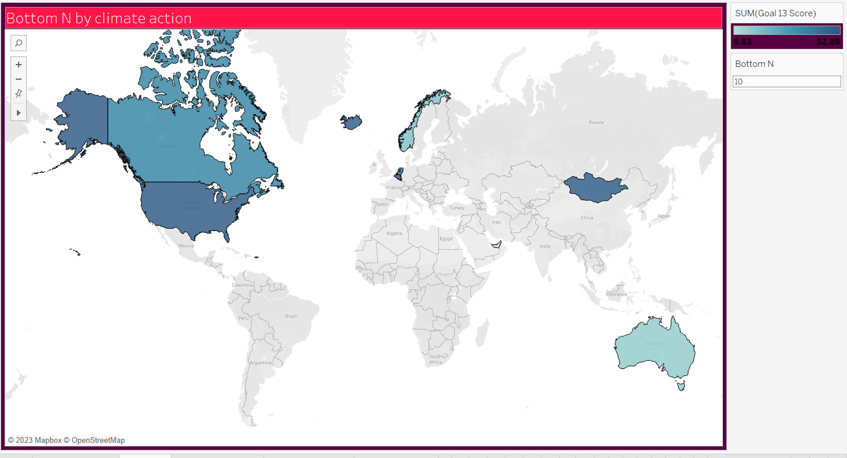

SDG GOAL 13 - Climate action:In this analysis we get bottom countries regarding climate action goal,which shows that developed countries like USA,Canada ,Norway etc are at bottom position that means they are developed countries in infrastructure,industries,technology but at same time they are pollutant countries.

India is having 94.28 score with “green” goal rating for sdg 13(climate action).this shows our nation having good nature and atmosphere.

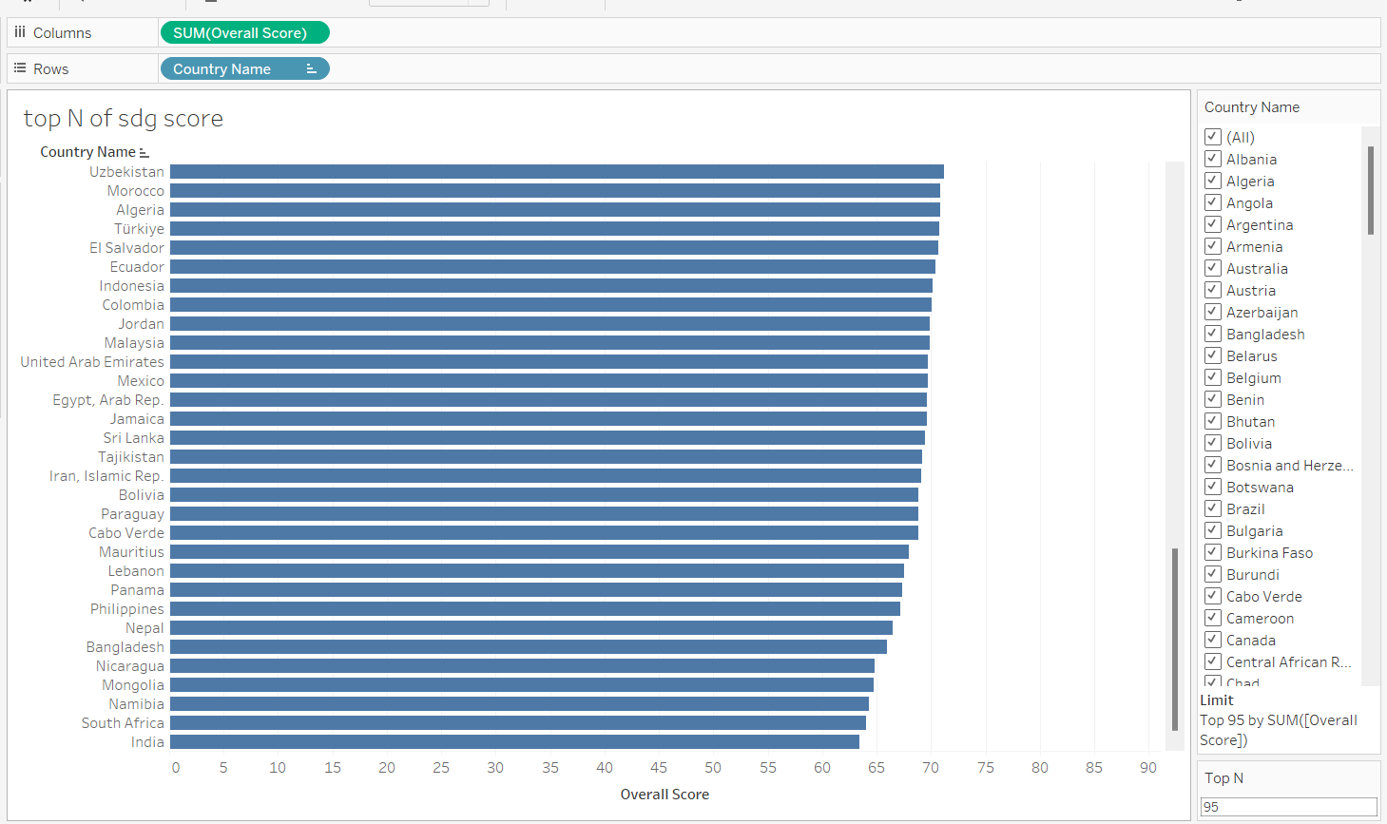

According to overall sdg goals score India is at 95th position .there are 193 nations in world in which India occupy 95th place this is quite good but not satisfying our goal .We recquire more result to achive our goal.First we need to compare our score with top countries and then come towards the aspect which have to follow to get success.This might be separate big task which leads towards functionality and time consuming process not possible getting instant result.

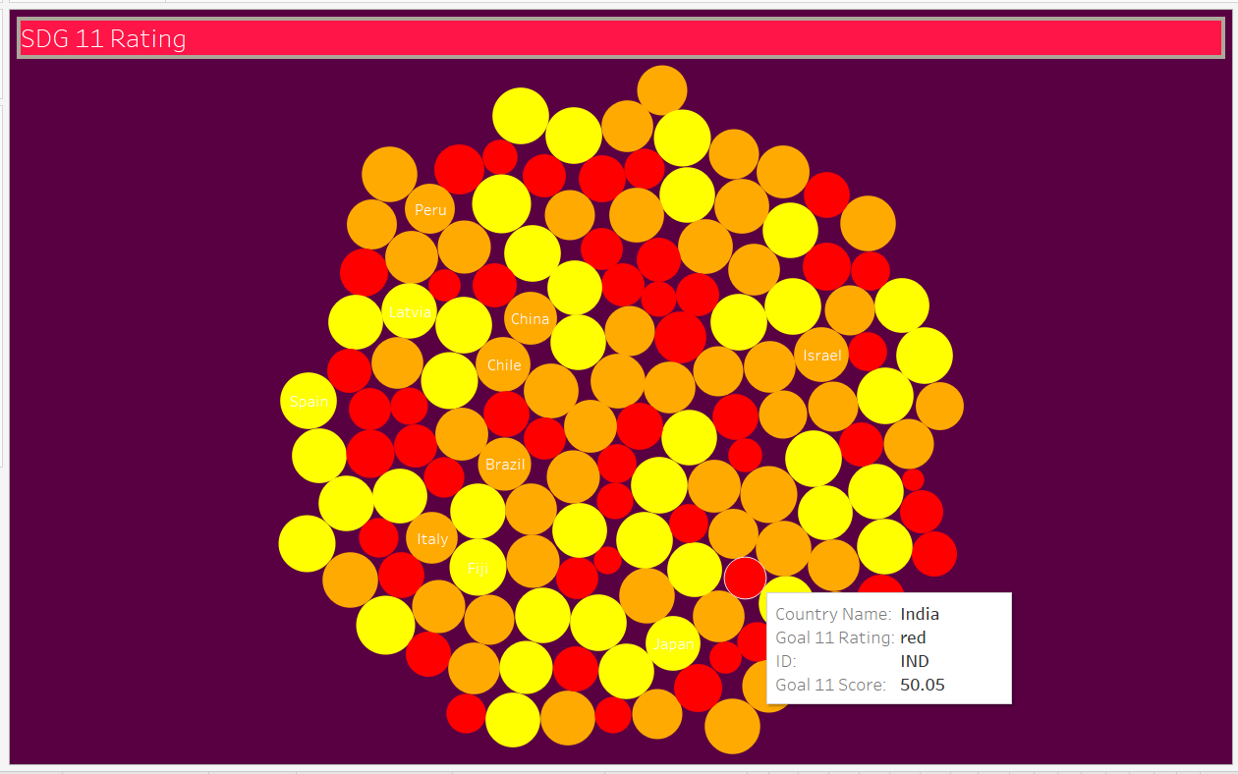

SDG 11 - SUSTAINABLE CITIES AND COMMUNITIES

As we see here India having 50.05 score with Red rating for this sdg goal 11.There is no one country in world who getting Green rating for this goal that means almost world goes throgh this problem of not meeting expectations of this goal that is –“ Goal 11 is about making cities and human settlements inclusive, safe, resilient and sustainable. Cities represent the future of global living “.

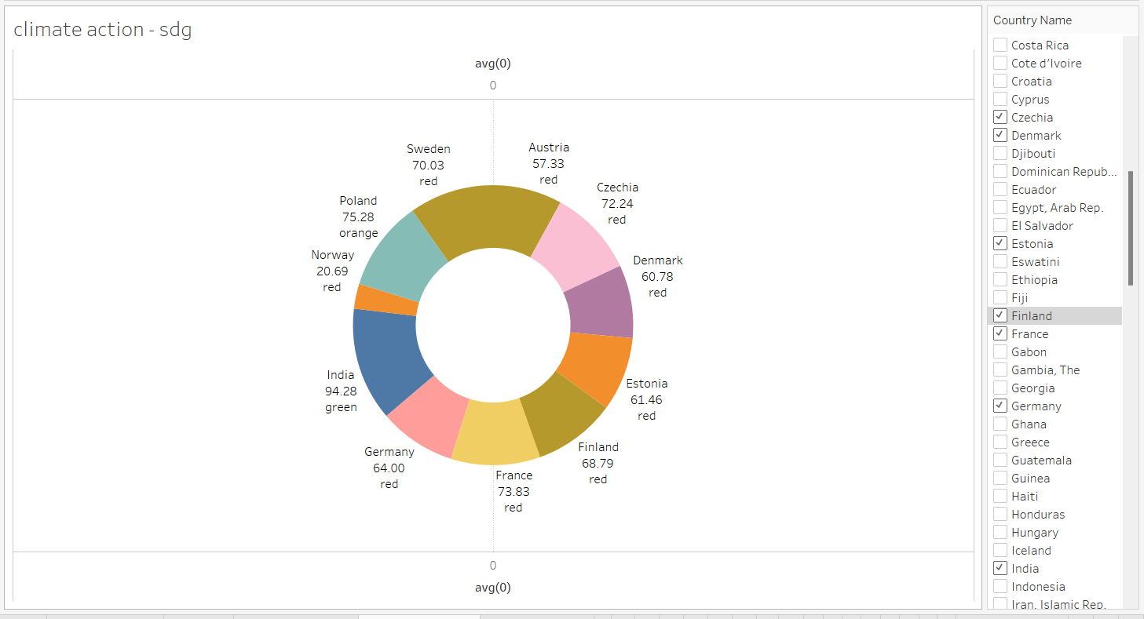

Here we compare ,all countries (which getting high score in overall SDG goals) with our country score in sdg goal 13 that is climate action.this is most important fact because this proves our nation although not getting high score in overall sdg goals but we satisfying- Goal 13 i.e. urgent actions to combat climate change and its impacts.  Climate change and environmental degradation are equity issues that undermine the rights of every child, especially the most disadvantaged. The realization of children’s rights, as embedded throughout the SDGs, are contingent on taking action to address and adapt to climate change.

Norway, Finland, Germany, Denmark, Austria etc are top countries according to overall sdg goals score but fail in this sdg goal at another hand india is good in this sdg

India has made significant progress towards achieving the Sustainable Development Goals (SDGs) by 2023. According to the Sustainable Development Report 2023, India's overall SDG score is 63.5, which puts it at rank 112 out of 166 countries. This is a significant improvement from India's rank of 117 in 2021.

Here is a brief overview of India's progress on some of the key SDGs by 2023:

**SDG 1: No Poverty**

India has made significant progress in reducing poverty in recent years. The poverty rate has declined from 21.2% in 2011-12 to 10.1% in 2019-20. However, the COVID-19 pandemic has pushed millions of people back into poverty. The government is implementing a number of schemes to help the poor, including the Pradhan Mantri Garib Kalyan Yojana and the National Food Security Act.

**SDG 2: Zero Hunger**

India has made significant progress in reducing hunger in recent years. The prevalence of undernourishment has declined from 15.9% in 2011-12 to 10.3% in 2019-20. However, the COVID-19 pandemic has had a negative impact on food security. The government is implementing a number of schemes to help the hungry, including the Pradhan Mantri Garib Kalyan Anna Yojana and the National Food Security Act.

**SDG 3: Good Health and Well-being**

India has made significant progress in improving health outcomes in recent years. The life expectancy at birth has increased from 65.8 years in 2011-12 to 69.2 years in 2019-20. The maternal mortality ratio has declined from 167 deaths per 100,000 live births in 2011-12 to 113 deaths per 100,000 live births in 2019-20. However, there are still significant challenges, such as high rates of malnutrition and stunting among children. The government is implementing a number of schemes to improve health outcomes, including the National Health Mission and the Ayushman Bharat Pradhan Mantri Jan Arogya Yojana.

**SDG 4: Quality Education**

India has made significant progress in increasing access to education in recent years. The net enrollment ratio for primary education is now 99.6%, and the net enrollment ratio for secondary education is now 88.3%. However, there are still significant challenges, such as high dropout rates and low quality of education. The government is implementing a number of schemes to improve education, including the Sarva Shiksha Abhiyan and the Rashtriya Madhyamik Shiksha Abhiyan.

**SDG 5: Gender Equality**

India has made some progress in promoting gender equality in recent years. For example, the female labor force participation rate has increased from 26.3% in 2011-12 to 29.6% in 2019-20. However, there are still significant challenges, such as high rates of gender-based violence and discrimination against women. The government is implementing a number of schemes to promote gender equality, such as the Beti Bachao Beti Padhao Yojana and the Mission Shakti.

India is still facing a number of challenges in achieving the SDGs by 2030. However, the country has made significant progress in recent years, and the government is committed to achieving the SDGs.

In addition to the SDGs listed above, India has also made significant progress on a number of other SDGs, such as access to clean water and sanitation, affordable and clean energy, and sustainable cities and communities.

The Indian government has launched a number of initiatives to achieve the SDGs, including the SDG India Index and Dashboard, the NITI Aayog SDG Voluntary National Review, and the SDG India Platform. These initiatives are helping to track India's progress on the SDGs and identify areas where further action is needed.

India has set ambitious goals for itself to achieve the Sustainable Development Goals (SDGs) by 2024. Some of the key goals that the country is working towards include:

* No Poverty: India aims to reduce the poverty rate to less than 10% by 2024. This will require sustained economic growth and job creation, as well as policies that target the poorest and most vulnerable sections of society.
* Zero Hunger: India aims to achieve zero hunger by 2024. This will require increasing agricultural productivity, reducing food waste, and ensuring that everyone has access to nutritious food.
* Good Health and Well-being: India aims to improve the overall health and well-being of its population by 2024. This will require reducing child and maternal mortality rates, improving access to quality healthcare, and combating communicable and non-communicable diseases.
* Quality Education: India aims to ensure that all children have access to quality education up to secondary level by 2024. This will require improving the quality of teaching and learning, reducing school dropout rates, and increasing access to education for girls and children from disadvantaged groups.
* Gender Equality: India aims to achieve gender equality in all spheres of life by 2024. This will require eliminating gender-based discrimination and violence, promoting women's empowerment, and increasing women's participation in the workforce and decision-making.
* Clean Water and Sanitation: India aims to ensure that everyone has access to safe drinking water and adequate sanitation facilities by 2024. This will require expanding the coverage of piped water supply and sewerage systems, and improving the management of wastewater and solid waste.
* Affordable and Clean Energy: India aims to increase the share of renewable energy in its total energy mix to 40% by 2024. This will require investing in renewable energy technologies, improving energy efficiency, and reducing energy consumption.
* Decent Work and Economic Growth: India aims to create 100 million new jobs and achieve sustained economic growth of 8% per year by 2024. This will require promoting entrepreneurship, investing in infrastructure, and developing skills that are relevant to the job market.
* Industry, Innovation and Infrastructure: India aims to become a global leader in manufacturing and innovation by 2024. This will require investing in research and development, improving the quality of infrastructure, and creating a conducive environment for businesses to thrive.
* Sustainable Cities and Communities: India aims to make its cities and communities more sustainable by 2024. This will require improving urban planning, promoting public transportation, and reducing pollution.

These are just some of the key SDG goals that India is working towards by 2024. Achieving these goals will require a concerted effort from all stakeholders, including the government, businesses, civil society, and individuals.

Here are some specific steps that India is taking to achieve these goals:

* No Poverty: The government is implementing a number of programs to reduce poverty, including the Pradhan Mantri Jan Dhan Yojana, which provides financial inclusion to the poor, and the Pradhan Mantri Garib Kalyan Yojana, which provides social security benefits to the poor and vulnerable.
* Zero Hunger: The government is implementing a number of programs to achieve zero hunger, including the National Food Security Act, which guarantees subsidized food to millions of Indians, and the Poshan Abhiyan, which aims to improve the nutritional status of children and women.
* Good Health and Well-being: The government is implementing a number of programs to improve the overall health and well-being of its population, including the Ayushman Bharat Yojana, which provides health insurance to over 500 million Indians, and the National Mission on Health, which aims to improve access to quality healthcare services.
* Quality Education: The government is implementing a number of programs to ensure that all children have access to quality education up to secondary level, including the Sarva Shiksha Abhiyan, which provides universal elementary education, and the Rashtriya Madhyamik Shiksha Abhiyan, which provides universal secondary education.
* Gender Equality: The government is implementing a number of programs to achieve gender equality, including the Beti Bachao Beti Padhao Yojana, which aims to improve the child sex ratio and increase girls' enrollment in schools, and the Pradhan Mantri Ujjwala Yojana, which provides free cooking gas connections to women from below-poverty-line households.
* Clean Water and Sanitation: The government is implementing a number of programs to ensure that everyone has access to safe drinking water and adequate sanitation facilities, including the Swachh Bharat Mission, which aims to make India open defecation-free, and the National Rural Drinking Water Programme, which aims to provide universal access to safe drinking water.
* Affordable and Clean Energy: The government is investing heavily in renewable energy technologies, such as

**Suggestions:**

1)Compare our data with other countries who having great score.

2)Make use of our youth power to getting success, focus mainly on youth to implements different schemes which beneficial for them like- change in education system, nature friendly activities, healthy habits programs etc.

3)Look at the goals in which we lagging and focus on this with another countries how they work different than us.

4)Trying to meet goals by putting more efforts it’s not easy as it looks but our nation having great population so find such activities which get positive result, mainly govt need to become strict to implements this activities.